Q 1.Consider a grammar G = (V , T , P , S) where-
- V = { S }
- T = { a , b }
- P = { S → aSbS , S → bSaS , S → ∈ }
- S = { S }

- This grammar is an example of a context free grammar.
- It generates the strings having equal number of a’s and b’s.

Q2. Language: of all strings having many 0’s, defined over {0}
Regular Expression: a⁺
Context Free Grammar: S ⇒ 0S | 0
Q.3
Language: of all strings having many 0’s or no zero, defined over {0}
Regular Expression: a*
Context Free Grammar: S ⇒ 0S | ε
Q4.
Language: of all strings having exactly one 0’s or exactly one 1, defined over {0,1}
Regular Expression: 0+1
Context Free Grammar: S ⇒ 0 | 1
Q 5. Language: of all strings having many 0’s or many 1’s or no zero or no one, defined over {0,1}
Regular Expression: (0+1)*
Context Free Grammar: S ⇒ 0S | 1S | ε

5. Built the CFG for the language of all those strings having 0 a’s or many a’s?
S ⇒ aS | ε
Now we can read multiple a’s from this CFG.
For example;
To read o a’s from S ⇒ aS | ε
S ⇒ aS | ε
S⇒ ε
To read 1 a from S ⇒ aS | ε
S ⇒ aS
S⇒ a ε
S⇒ a
To read 2 a from S ⇒ aS | ε
S ⇒ aS
S ⇒ aaS
S⇒ a ε
S⇒ a
and similarly, we can read many a’s from this CFG.

Q.7 Examples of CFG of odd Length strings
To read a;
CFG:
S → aX | bX
X→ aS | bS | ε
Path to Read the String
S ⇒ aX //Read first a.
X⇒ε //Read first aε.
finally, we can read it as a.
Congratulation, the string can be read and the machine can be stoped after successfully completing its task.
To read b;
CFG:
S → aX | bX
X→ aS | bS | ε
S ⇒ bX //Read first b.
X⇒ε //Read first bε.
finally, we can read it as b.
Q. 6
CFG {N,T,P,S} be
N = {S}, T = {a, b}, Starting symbol = S, P = S → SS | aSb | ε
One derivation from the above CFG is “abaabb”
S → SS → aSbS → abS → abaSb → abaaSbb → abaabb
Q.7. Verify the the string aabbabba for the CFG given by is valid,
- S → aB | bA
- A → a | aS | bAA
- B → b | bS | aBB

Q.8 Show the derivation tree for string "aabbbb" with the following grammar.
- S → AB | ε
- A → aB
- B → Sb

Q. 9 Grammar: S → ASB | c A → ε | aA B → ε | bB
Derivation Sequences for acb
S => ASB => aASB => aSB => acB => acbB => acb
S => ASB => ASbB => ASb => aAcb => aAcb => acb
S => ASB => AcB => aAcB => aAcbB => acbB => acb

Problem-10:

Consider the grammar-
S → bB / aA
A → b / bS / aAA
B → a / aS / bBB

For the string w = bbaababa, find-
- Leftmost derivation
- Rightmost derivation
- Parse Tree

Solution-

1. Leftmost Derivation-

S → bB
→ bbBB (Using B → bBB)
→ bbaB (Using B → a)
→ bbaaS (Using B → aS)
→ bbaabB (Using S → bB)
→ bbaabaS (Using B → aS)
→ bbaababB (Using S → bB)
→ bbaababa (Using B → a)

2. Rightmost Derivation-

S → bB
→ bbBB (Using B → bBB)
→ bbBaS (Using B → aS)
→ bbBabB (Using S → bB)
→ bbBabaS (Using B → aS)
→ bbBababB (Using S → bB)
→ bbBababa (Using B → a)
→ bbaababa (Using B → a)

3. Parse Tree-

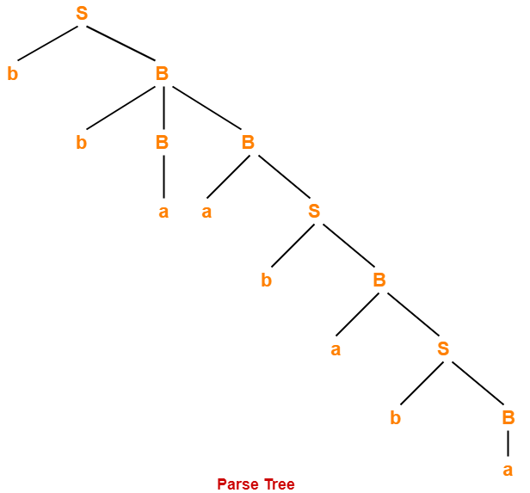

- Whether we consider the leftmost derivation or rightmost derivation, we get the above parse tree.
- The reason is given grammar is unambiguous.

Problem-11:

Consider the grammar-
S → A1B
A → 0A / ∈
B → 0B / 1B / ∈

For the string w = 00101, find-
- Leftmost derivation
- Rightmost derivation
- Parse Tree

Solution-

1. Leftmost Derivation-

S → A1B
→ 0A1B (Using A → 0A)
→ 00A1B (Using A → 0A)
→ 001B (Using A → ∈)
→ 0010B (Using B → 0B)
→ 00101B (Using B → 1B)
→ 00101 (Using B → ∈)

2. Rightmost Derivation-

S → A1B
→ A10B (Using B → 0B)
→ A101B (Using B → 1B)
→ A101 (Using B → ∈)
→ 0A101 (Using A → 0A)
→ 00A101 (Using A → 0A)
→ 00101 (Using A → ∈)

3. Parse Tree-

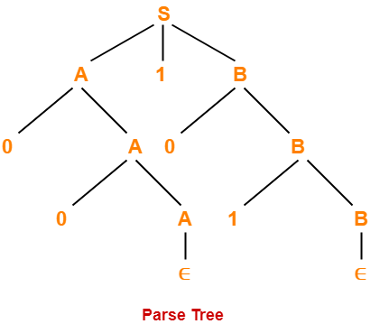

- Whether we consider the leftmost derivation or rightmost derivation, we get the above parse tree.
- The reason is given grammar is unambiguous.

Q. 12

Problem
Convert the following CFG into CNF
S → ASA | aB, A → B | S, B → b | ε

Solution
(1) Since S appears in R.H.S, we add a new state S₀ and S₀→S is added to the production set and it becomes −
S₀→S, S→ ASA | aB, A → B | S, B → b | ∈
(2) Now we will remove the null productions −
B → ∈ and A → ∈
After removing B → ε, the production set becomes −
S₀→S, S→ ASA | aB | a, A → B | S | ∈, B → b
After removing A → ∈, the production set becomes −
S₀→S, S→ ASA | aB | a | AS | SA | S, A → B | S, B → b
(3) Now we will remove the unit productions.
After removing S → S, the production set becomes −
S₀→S, S→ ASA | aB | a | AS | SA, A → B | S, B → b
After removing S₀→ S, the production set becomes −
S₀→ ASA | aB | a | AS | SA, S→ ASA | aB | a | AS | SA
A → B | S, B → b
After removing A→ B, the production set becomes −
S₀ → ASA | aB | a | AS | SA, S→ ASA | aB | a | AS | SA
A → S | b
B → b
After removing A→ S, the production set becomes −
S₀ → ASA | aB | a | AS | SA, S→ ASA | aB | a | AS | SA
A → b |ASA | aB | a | AS | SA, B → b
(4) Now we will find out more than two variables in the R.H.S
Here, S₀→ ASA, S → ASA, A→ ASA violates two Non-terminals in R.H.S.
Hence we will apply step 4 and step 5 to get the following final production set which is in CNF −
S₀→ AX | aB | a | AS | SA
S→ AX | aB | a | AS | SA
A → b |AX | aB | a | AS | SA
B → b
X → SA
(5) We have to change the productions S₀→ aB, S→ aB, A→ aB
And the final production set becomes −
S₀→ AX | YB | a | AS | SA
S→ AX | YB | a | AS | SA
A → b A → b |AX | YB | a | AS | SA
B → b
X → SA
Y → a

Example-13 – Let us take an example to convert CFG to CNF. Consider the given grammar G1:
S → ASB
A → aAS|a|ε
B → SbS|A|bb
Step 1. As start symbol S appears on the RHS, we will create a new production rule S0->S. Therefore, the grammar will become:
S0->S
S → ASB
A → aAS|a|ε
B → SbS|A|bb
Step 2. As grammar contains null production A-> ε, its removal from the grammar yields:
S0->S
S → ASB|SB
A → aAS|aS|a
B → SbS| A|ε|bb
Now, it creates null production B→ ε, its removal from the grammar yields:
S0->S
S → AS|ASB| SB| S
A → aAS|aS|a
B → SbS| A|bb
Now, it creates unit production B->A, its removal from the grammar yields:
S0->S
S → AS|ASB| SB| S
A → aAS|aS|a
B → SbS|bb|aAS|aS|a
Also, removal of unit production S0->S from grammar yields:
S0-> AS|ASB| SB| S
S → AS|ASB| SB| S
A → aAS|aS|a
B → SbS|bb|aAS|aS|a
Also, removal of unit production S->S and S0->S from grammar yields:
S0-> AS|ASB| SB
S → AS|ASB| SB
A → aAS|aS|a
B → SbS|bb|aAS|aS|a
Step 3. In production rule A->aAS |aS and B-> SbS|aAS|aS, terminals a and b exist on RHS with non-terminates. Removing them from RHS:
S0-> AS|ASB| SB
S → AS|ASB| SB
A → XAS|XS|a
B → SYS|bb|XAS|XS|a
X →a
Y→b
Also, B->bb can’t be part of CNF, removing it from grammar yields:
S0-> AS|ASB| SB
S → AS|ASB| SB
A → XAS|XS|a
B → SYS|VV|XAS|XS|a
X → a
Y → b
V → b
Step 4: In production rule S0->ASB, RHS has more than two symbols, removing it from grammar yields:
S0-> AS|PB| SB
S → AS|ASB| SB
A → XAS|XS|a
B → SYS|VV|XAS|XS|a
X → a
Y → b
V → b
P → AS
Similarly, S->ASB has more than two symbols, removing it from grammar yields:
S0-> AS|PB| SB
S → AS|QB| SB
A → XAS|XS|a
B → SYS|VV|XAS|XS|a
X → a
Y → b
V → b
P → AS
Q → AS
Similarly, A->XAS has more than two symbols, removing it from grammar yields:
S0-> AS|PB| SB
S → AS|QB| SB
A → RS|XS|a
B → SYS|VV|XAS|XS|a
X → a
Y → b
V → b
P → AS
Q → AS
R → XA
Similarly, B->SYS has more than two symbols, removing it from grammar yields:
S0 -> AS|PB| SB
S → AS|QB| SB
A → RS|XS|a
B → TS|VV|XAS|XS|a
X → a
Y → b
V → b
P → AS
Q → AS
R → XA
T → SY
Similarly, B->XAX has more than two symbols, removing it from grammar yields:
S0-> AS|PB| SB
S → AS|QB| SB
A → RS|XS|a
B → TS|VV|US|XS|a
X → a
Y → b
V → b
P → AS
Q → AS
R → XA
T → SY
U → XA

PRACTICE PROBLEMS BASED ON CHOMSKY NORMAL FORM-

Problem-01:

Convert the given grammar to CNF-
S → aAD
A → aB / bAB
B → b
D → d

Solution-

Step-01:

The given grammar is already completely reduced.

Step-02:

The productions already in chomsky normal form are-
B → b ………..(1)
D → d ………..(2)
These productions will remain as they are.

The productions not in chomsky normal form are-
S → aAD ………..(3)
A → aB / bAB ………..(4)
We will convert these productions in chomsky normal form.

Step-03:

Replace the terminal symbols a and b by new variables C_{a} and C_{b}.

This is done by introducing the following two new productions in the grammar-
C_{a} → a ………..(5)
C_{b} → b ………..(6)

Now, the productions (3) and (4) modifies to-
S → C_{a}AD ………..(7)
A → C_{a}B / C_{b}AB ………..(8)

Step-04:

Replace AD and AB by new variables C_{AD} and C_{AB} respectively.

This is done by introducing the following two new productions in the grammar-
C_{AD} → AD ………..(9)
C_{AB} → AB ………..(10)

Now, the productions (7) and (8) modifies to-
S → C_{a}C_{AD} ………..(11)
A → C_{a}B / C_{b}C_{AB} ………..(12)

Step-05:

From (1), (2), (5), (6), (9), (10), (11) and (12), the resultant grammar is-

S → C_{a}C_{AD}
A → C_{a}B / C_{b}C_{AB}
B → b
D → d
C_{a} → a
C_{b} → b
C_{AD} → AD
C_{AB} → AB

This grammar is in chomsky normal form.

Problem-02:

Convert the given grammar to CNF-
S → 1A / 0B
A → 1AA / 0S / 0
B → 0BB / 1S / 1

Solution-

Step-01:

The given grammar is already completely reduced.

Step-02:

The productions already in chomsky normal form are-
A → 0 ………..(1)
B → 1 ………..(2)
These productions will remain as they are.

The productions not in chomsky normal form are-
S → 1A / 0B ………..(3)
A → 1AA / 0S ………..(4)
B → 0BB / 1S ………..(5)
We will convert these productions in chomsky normal form.

Step-03:

Replace the terminal symbols 0 and 1 by new variables C and D.

This is done by introducing the following two new productions in the grammar-
C → 0 ………..(6)
D → 1 ………..(7)

Now, the productions (3), (4) and (5) modifies to-
S → DA / CB ………..(8)
A → DAA / CS ………..(9)
B → CBB / DS ………..(10)

Step-04:

Out of (8), (9) and (10), the productions already in Chomsky Normal Form are-
S → DA / CB ………..(11)
A → CS ………..(12)
B → DS ………..(13)
These productions will remain as they are.

The productions not in chomsky normal form are-
A → DAA ………..(14)
B → CBB ………..(15)
We will convert these productions in Chomsky Normal Form.

Step-05:

Replace AA and BB by new variables E and F respectively.

This is done by introducing the following two new productions in the grammar-
E → AA ………..(16)
F → BB ………..(17)

Now, the productions (14) and (15) modifies to-
A → DE ………..(18)
B → CF ………..(19)

Step-06:

From (1), (2), (6), (7), (11), (12), (13), (16), (17), (18) and (19), the resultant grammar is-

S → DA / CB
A → CS / DE / 0
B → DS / CF / 1
C → 0
D → 1
E → AA
F → BB

This grammar is in chomsky normal form.

To gain better understanding about Chomsky Normal Form,

